Drawings as Objects of Knowledge
Transpositions in architectural archives

The Roosenberg Talks, session 1
Dep. of Architecture, KU Leuven

28-29 April 2022

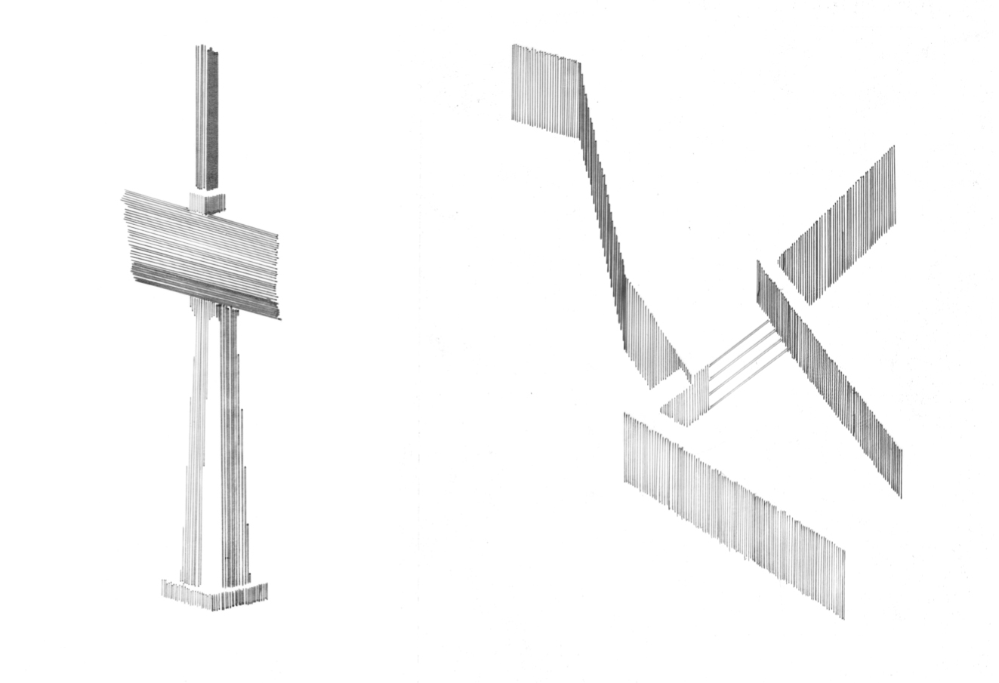Student Sylvain Wuyts, Redrawing time in Fernando Tavorá’s casa De Pardelhas, Studio Structural Contingencies, Faculty of Architecture KU Leuven, tutors Caroline Voet and Eireen Schreurs, 2021-2022.

Location
Dom Hans van der Laan’s Roosenberg Abbey, Waasmunster, Belgium.

Key notes
Elizabeth Hatz (SAUL, KTH)
Michael Merrill (KIT)
Helen Thomas (ETH Zurich)

The conference will be held in the presence of the participants at Roosenberg Abbey.
In due course, a second symposium will be organised digitally. For those who would like to submit an abstract, but are unable to attend: you will be peer reviewed for participation in the second digital symposium.

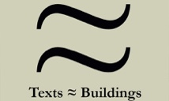

Call for papers

Architects do not make buildings, they design them through drawing (Evans, 1997). From the sketch to the 1:1 detail, it is the manipulation of the actual material into structure and enclosures and how this relates to spatial effects is conceptualized and imagined. Current changing attitudes towards preservation, reconversion and care of existing buildings (Otero Pailos, Langdalen, Arhenius, 2016) call for research on the design and conceptualization of these buildings. Nevertheless, the ‘false divide’ between architectural history-theory and design knowledge (Pelkonen, 2021) problematizes this. The symposium aims to challenge this gap, by turning to drawings and their buildings as ‘tools of knowledge’. It opens up the archives and the design knowledge they produce, exploring how they can be made operative within the field of architectural history and theory, in order to feed the current design practice.
The hand of the architect is informed by a kaleidoscope network of references and influences that are at work in processes of copy-paste, analogy, conscious integration or deliberate misplacement. Albena Yaneva described how the act of recollecting this design process relies on the assumption shared by architects that buildings are pragmatically knowable, not symbolically (Yaneva 2012,2016). Within the design process, the envisaged aesthetic experience, like the ethical experience, is self-contained and has an ulterior purposefulness. This echoes the pedagogical concept of ‘lived’ or ‘direct experience’, which, as Zeynep Çelik wrote, reveals a deep-rooted belief in the existence of “a non-discursive, non-conceptual way of knowing that could nonetheless compete in its rigor with reason realized through language, concepts or logic” (Çelik Alexander 2017).
This first series of talks focusses on archival drawings and how they can be read as ‘objects of knowledge’, exploring the design expertise and purposefulness they express, and the ways in which they initiated an exchange within the office and studio practice. Two (intertwined) perspectives are put forward:
Firstly, as a primary source, the original drawing is an object of archival study that is situated within a network of design iterations towards a building. In this process of relating, drawings are very particular beings, specific creatures in the architectural office, fostering an active participation in design thinking, not just as final drawings, but as working drawings that have helped the architects to generate knowledge on their project. Dissecting these layered codes is about spending time with the drawings in the archives, and experiencing the building and its operation.
The second perspective of the symposium puts the analytical drawing forward as a research tool, an ‘object of knowledge’ that requests the active participation and drawing skills of the researcher. The aim of these research drawings, or re-drawings, is to go beyond the singularity and individuality of the creator, moving from authorship or theoretical contextualization towards the distillation of histories of methods and tools, didactics and design practices. What kinds of knowledge are hidden in the archives, what are the conditions, methods and interpretations that can reveal design knowledge?

Papers are invited that address both perspectives through a case study. Please send an abstract of 300 words + CV (150 words) to research.arch@kuleuven.be by 21 February.

Scientific Committee
Tom Avermaete (ETH Zurich)
Klaske Havik (TU Delft)
Koenraad Van Cleempoel (Hasselt University)
Matthew Ozga-Lawn (Newcastle University)
Caroline Voet (KU Leuven)
Rajesh Heynickx (KU Leuven)

Organisation
Caroline Voet (KU Leuven)
Eireen Schreurs (KU Leuven / U Antwerp / TU Delft)
Laura Lievevrouw (KU Leuven)

As part of the Scientific Research Network Texts≈ Buildings: Dissecting Transpositions in Architectural Knowledge (1880/1980).
Funded by the FWO.

